Jing Zhang

Visual communication II

Bio interactive website

Inspiration(sample):

<http://dada-data.net/en/depot>

Hamburger nav. in the left-up side of the page, by click the hamburger menu, it goes to a page like the the sample website. Following is the page when you click the hamburger menu:

The text in this page will be INTRO, ATARI/ALINEN GARDEN, MOONDUST, VPL, VIRTUAL REALITY&MUSIC, INTERNET, DIGITAL MAOISM, KINECT

The text will change the color when the computer mouse on it.

“Jaron Lanier” will be on the right-up side of the page, just like the sample website.

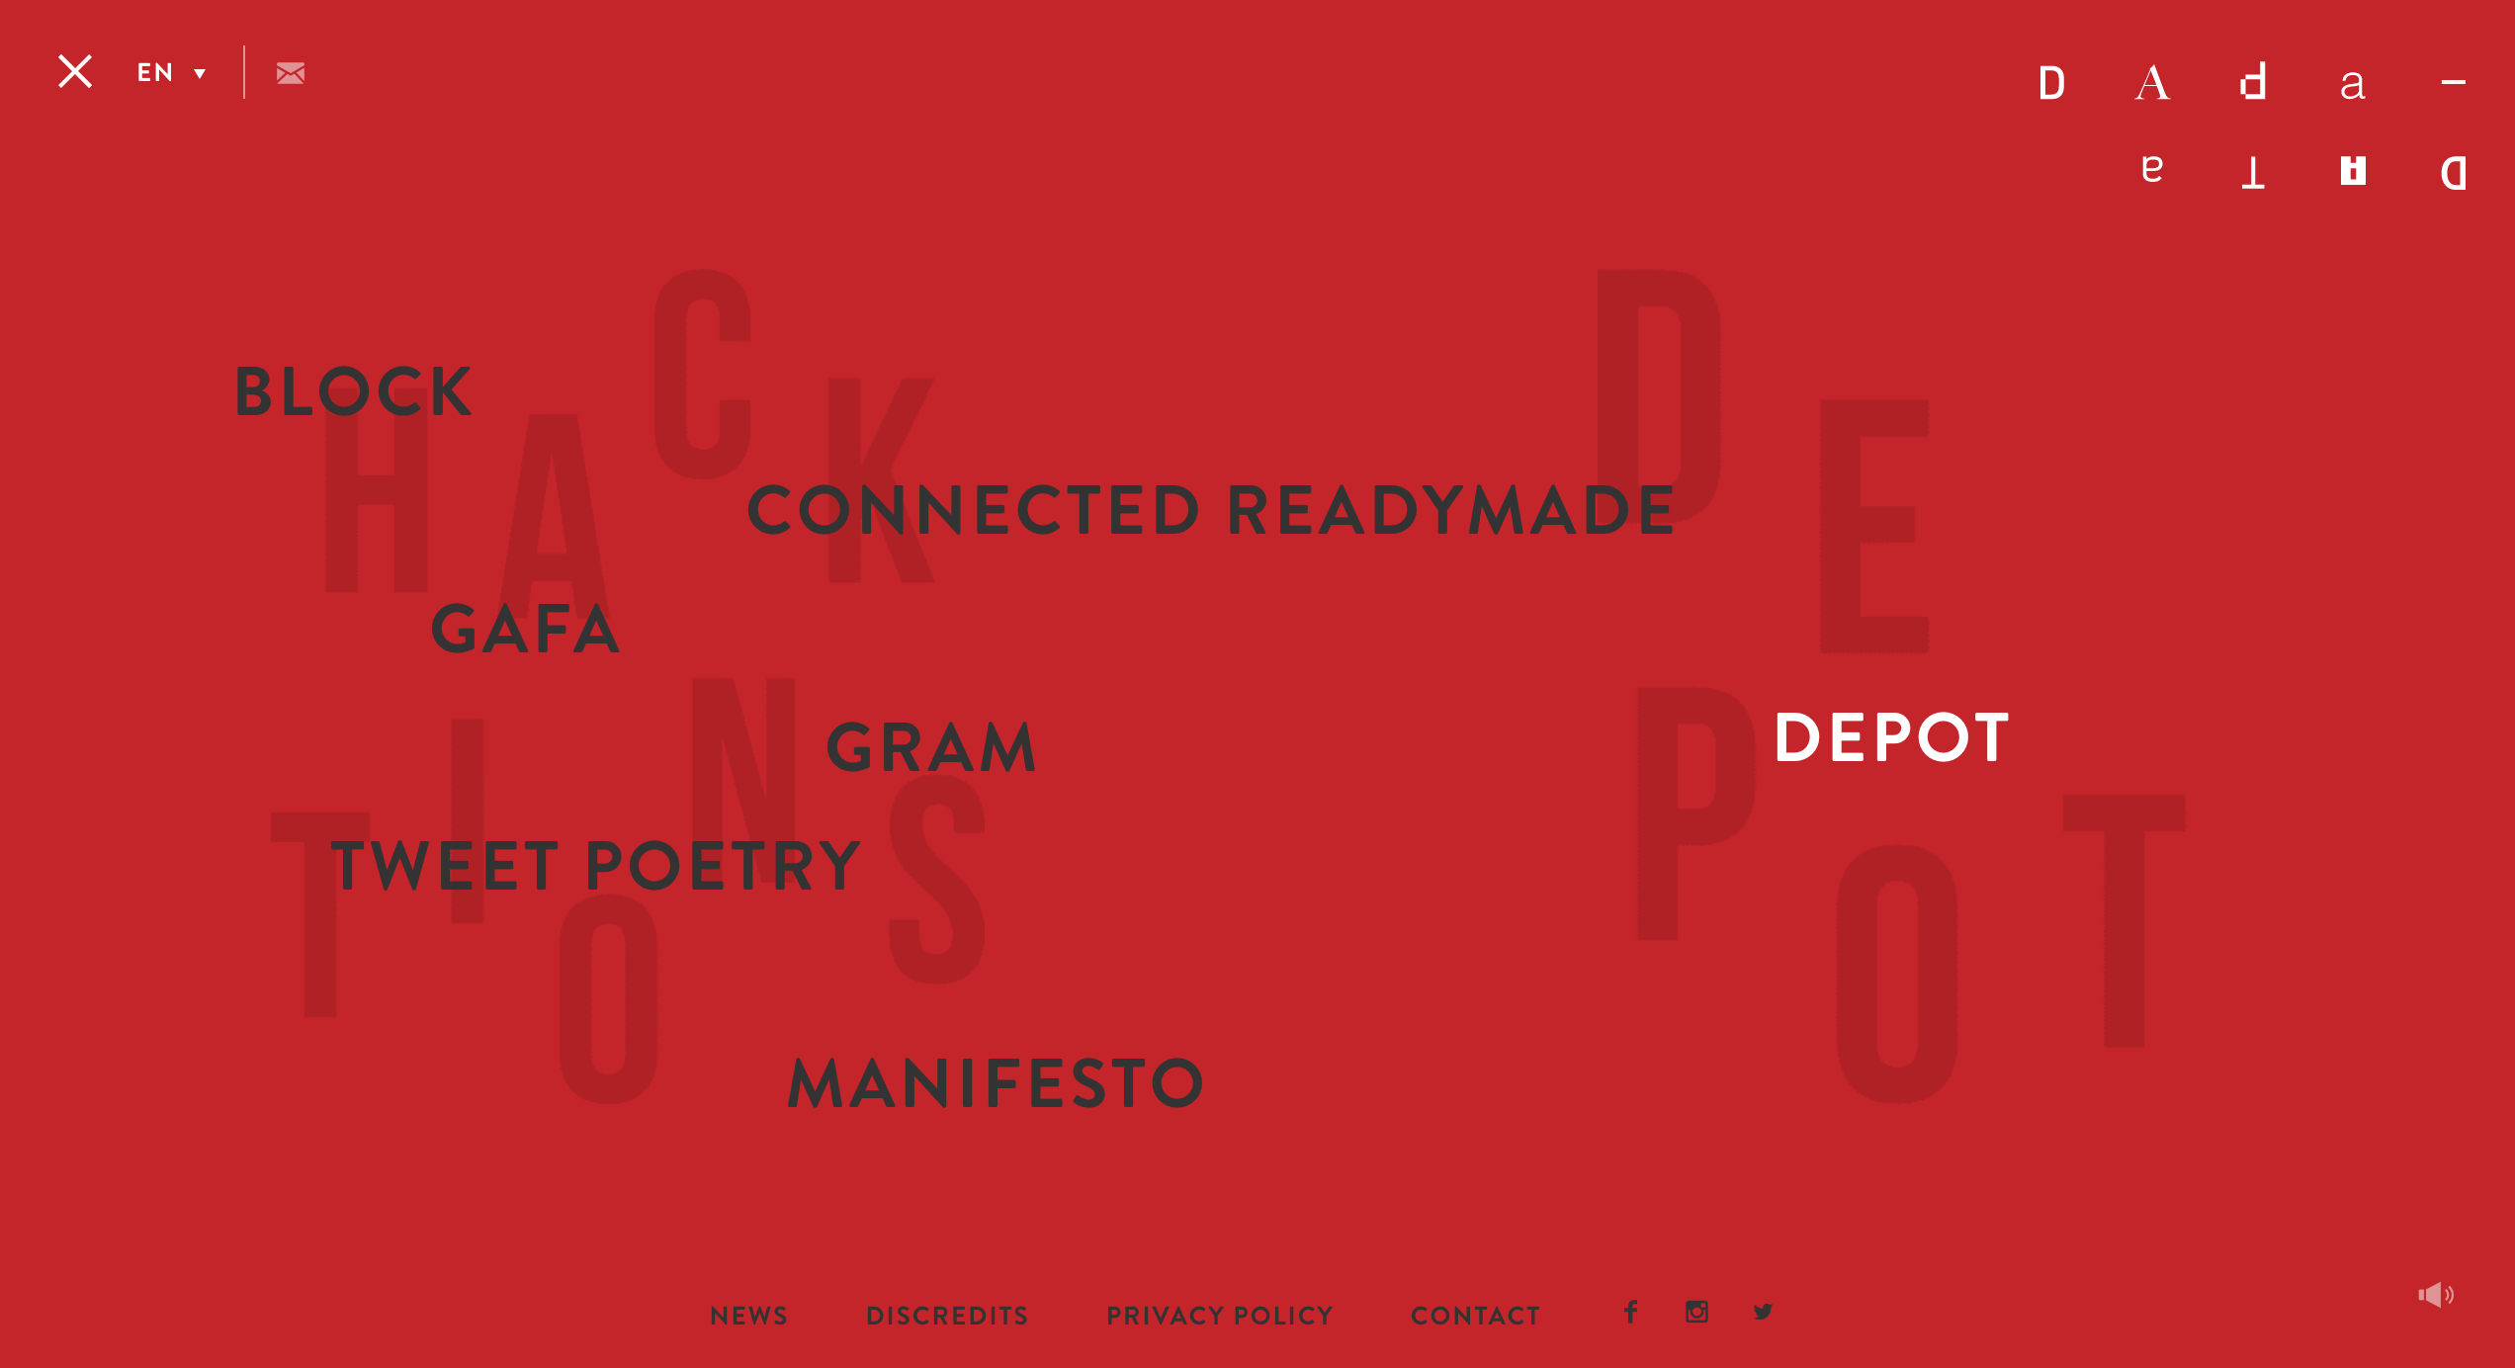

Page1-page3, page 7 to page 10, you can use the mouse click and swipe it to the next pages, just like the sample website did.

Page4-page6 will be your idea fade in/out.

Outline - Jaron Lanier

Page 1: Intro

* Title: “Who Owns the Future?”
* Image: pg1-intro.jpg -&- pg1-jaron-lanier.jpg
* Source: http://www.jaronlanier.com/

Page 2: Atari / Alien Garden (1982)

* Title: “The need for experimentation”
* Text: “The player controls an embryonic animal as it grows, survives and reproduces through 20 generations. Difficulty is introduced through the lack of instructions in the game. As such, the player must employ trial and error techniques to determine which flowers are edible.”
* Image: pg2-atari.svg -&- alien-garden.jpg
* Source: https://en.wikipedia.org/wiki/Alien_Garden

Page 3: Moondust (1983)

* Title: “The unexpected ephemerality of digital data.”
* Image: pg3-moondust.jpg
* Source: https://en.wikipedia.org/wiki/Moondust_(video_game)

Page 4: VPL – Data Glove (1985-1990)

* Title: “Goals: Bring programming to a mass audience.”
* Text: “Gestures can then be categorized into useful information, such as to recognize sign language or other symbolic functions.”
* Image: pg4-power-glove.jpg
* Source: https://en.wikipedia.org/wiki/VPL_Research -&- https://en.wikipedia.org/wiki/Wired_glove

Page 5: VPL – Surgical Simulation (1985-1990)

* Text: “Simulators are generally used to train medical students and surgeons…without the use of animals or cadavers…."
* Image: pg5-surgical-simulation-1.jpg & pg5-surgical-simulation-2.jpg
* Source: http://www.jaronlanier.com/general.html -&- https://en.wikipedia.org/wiki/Surgery_simulator

Page 6: VPL – Virtual Sets for TV Production (1985-1990)

* Text: “A key point of a virtual studio is that the real camera can move in 3D space, while the image of the virtual camera is being rendered in real-time from the same perspective.”
* Image: pg6-virtual-set-1.jpg -&- pg6-virtual-set-2.jpg
* Source: http://www.jaronlanier.com/general.html -&- https://en.wikipedia.org/wiki/Virtual_studio

Page 7: Virtual Reality Music (1996)

* Title: “Music From Inside Virtual Reality”
* Text: “[Flutes are] bent and twisted inside virtual reality by my motions while I play them, which definitely does make new sounds”.
* Image: pg7-vr-music-1.jpg -&- pg7-vr-music-2.jpg
* Source: http://www.allmusic.com/artist/jaron-lanier-mn0000178526/biography

Page 8: Internet2 (1997-2001)

* Text: “A set of technologies which allow a person to feel as if they were present, [to be] at a place other than their true location.”
* Image: pg8-telepresence.jpg
* Source: https://en.wikipedia.org/wiki/Telepresence

Page 9: Digital Maoism (2006)

* Title: “Digital Maoism”
* Text: “If we start to believe that the Internet itself is an entity that has something to say, we’re devaluing those people [creating the content] and making ourselves into idiots.”
* Image: pg9-digital-maoism.jpg
* Source: https://en.wikipedia.org/wiki/Jaron_Lanier#Wikipedia_and_the_omniscience_of_collective_wisdom

Page 10: Kinect (2011)

* Text/Quote: “The most important thing about virtual reality isn’t the idea that you’re seeing this dramatic 3D thing. [It’s] that you experience yourself in a different way than you ever have before.”
* Image: pg10-kinect.jpg
* Source: http://www.geekwire.com/2011/virtual-reality-visionary-jaron-lanier-microsoft-gig-kinect-beautiful-exciting/

More